Exercise-4 Name: M.Rohith
26-03-2024 3122 21 5001 085

DATABASE SERVLET WEB APPLICATION USING TOMCAT SERVER

Aim:

Develop a simple web application with MySql database and Tomcat Server Authentication Application.

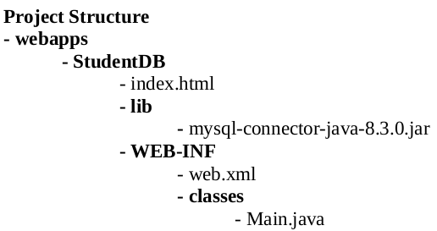

Program code:

index.html

<!DOCTYPE html>
<html lang="en">
<head>
<meta charset="UTF-8">
<meta name="viewport" content="width=device-width, initial-scale=1.0">
<title>Student Web App</title>
<style>
body{
height: 100%;
width: 100%;
display: flex;
align-items: center;
justify-content: center;
background-color: lightcoral;
}
.content{
height: 70%;
width: 400px;
background-color: red;
padding: 5%;
}
h1{
text-align: center;
}
label{
padding: 10px;
display: block;
}
button{
margin-left: 35%;
padding: 4px 30px;
margin-top: 20px;
}
</style>
</head>
<body>

<section class="content">
<h1>LOGIN</h1>
<form action="login" method="get">
<label for="name">Username: <input type="text" name="username"></label>
<label for="age">Password: <input type="text" name="password"></label>
<button type="submit">Login</button>
</form>
</section>
</body>
</html>

web.xml

<web-app>
<servlet>
<servlet-name>Main</servlet-name>
<servlet-class>Main</servlet-class>
</servlet>
<servlet-mapping>
<servlet-name>Main</servlet-name>
<url-pattern>/login</url-pattern>
</servlet-mapping>
<welcome-file-list>
<welcome-file>index.html</welcome-file>
</welcome-file-list>
</web-app>

Main.java

import java.io.*;
import java.sql.Connection;
import java.sql.DriverManager;
import java.sql.PreparedStatement;
import java.sql.ResultSet;
import java.sql.SQLException;
import javax.servlet.*;
import javax.servlet.http.*;

public class Main extends HttpServlet {
private static final String URL = "jdbc:mysql://localhost:3306/student";
private static final String USERNAME = "user";
private static final String PASSWORD = "password";

static {
try {
Class.forName("com.mysql.cj.jdbc.Driver");
} catch (ClassNotFoundException e) {
throw new RuntimeException("Error loading MySQL JDBC driver", e);
}
}

public void doGet(HttpServletRequest request, HttpServletResponse response)
throws IOException, ServletException {
response.setContentType("text/html");
PrintWriter out = response.getWriter();

String username = request.getParameter("username");
String password = request.getParameter("password");

try (Connection connection = DriverManager.getConnection(URL, USERNAME, PASSWORD)) {
String sql = "SELECT * FROM cse WHERE name = ? AND password = ?";
try (PreparedStatement statement = connection.prepareStatement(sql)) {
statement.setString(1, username);
statement.setString(2, password);

try (ResultSet resultSet = statement.executeQuery()) {
if (resultSet.next()) {
out.println("<html><head><title>Login Success</title></head><body>");
out.println("<h2>Login Success</h2>");
out.println("<h2>Hello " + username + "!</h2>");
out.println("</body></html>");
} else {
out.println("<html><head><title>User Not Found</title></head><body>");
out.println("<h2>User Not Found</h2>");
out.println("</body></html>");
}
}
}
} catch (SQLException e) {
out.println("<html><head><title>Database Error</title></head><body>");
out.println("<h2>Database Error</h2>");
out.println("<p>" + e.getMessage() + "</p>");
out.println("</body></html>");
}
}
}

Output:

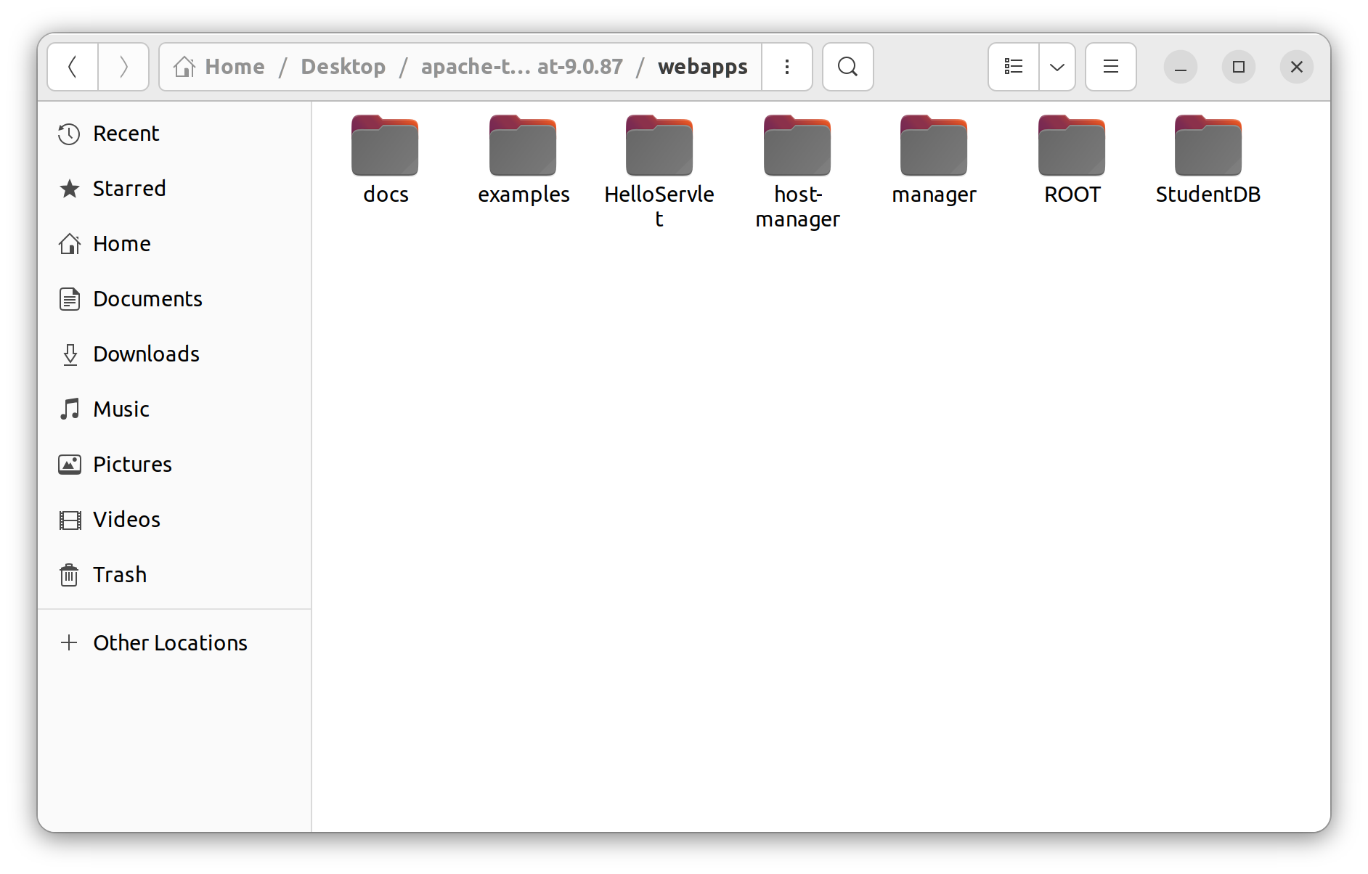
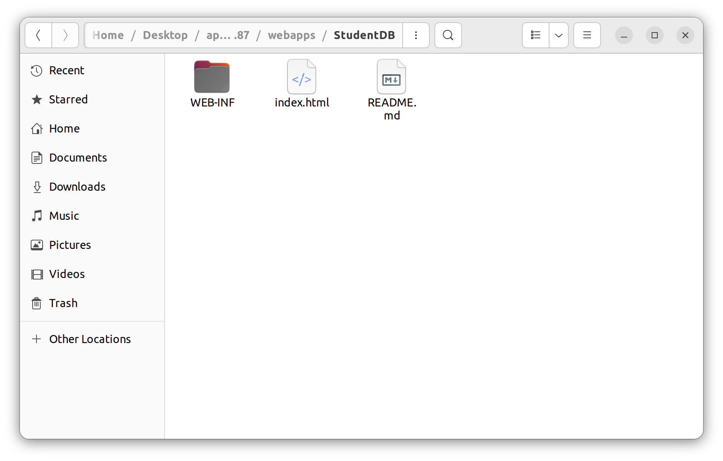

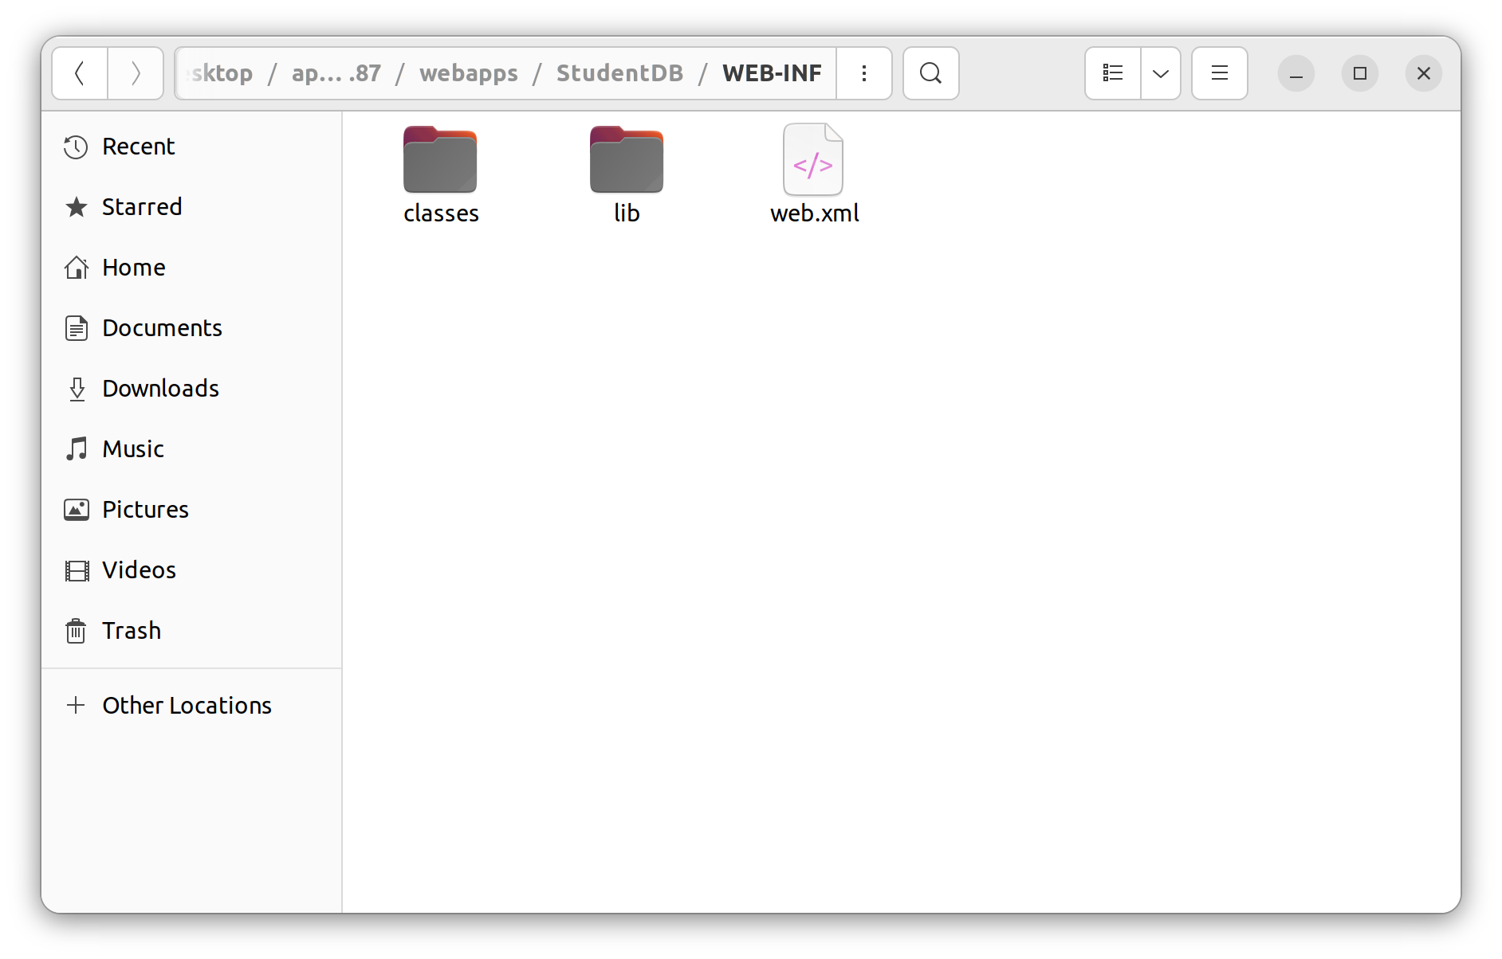
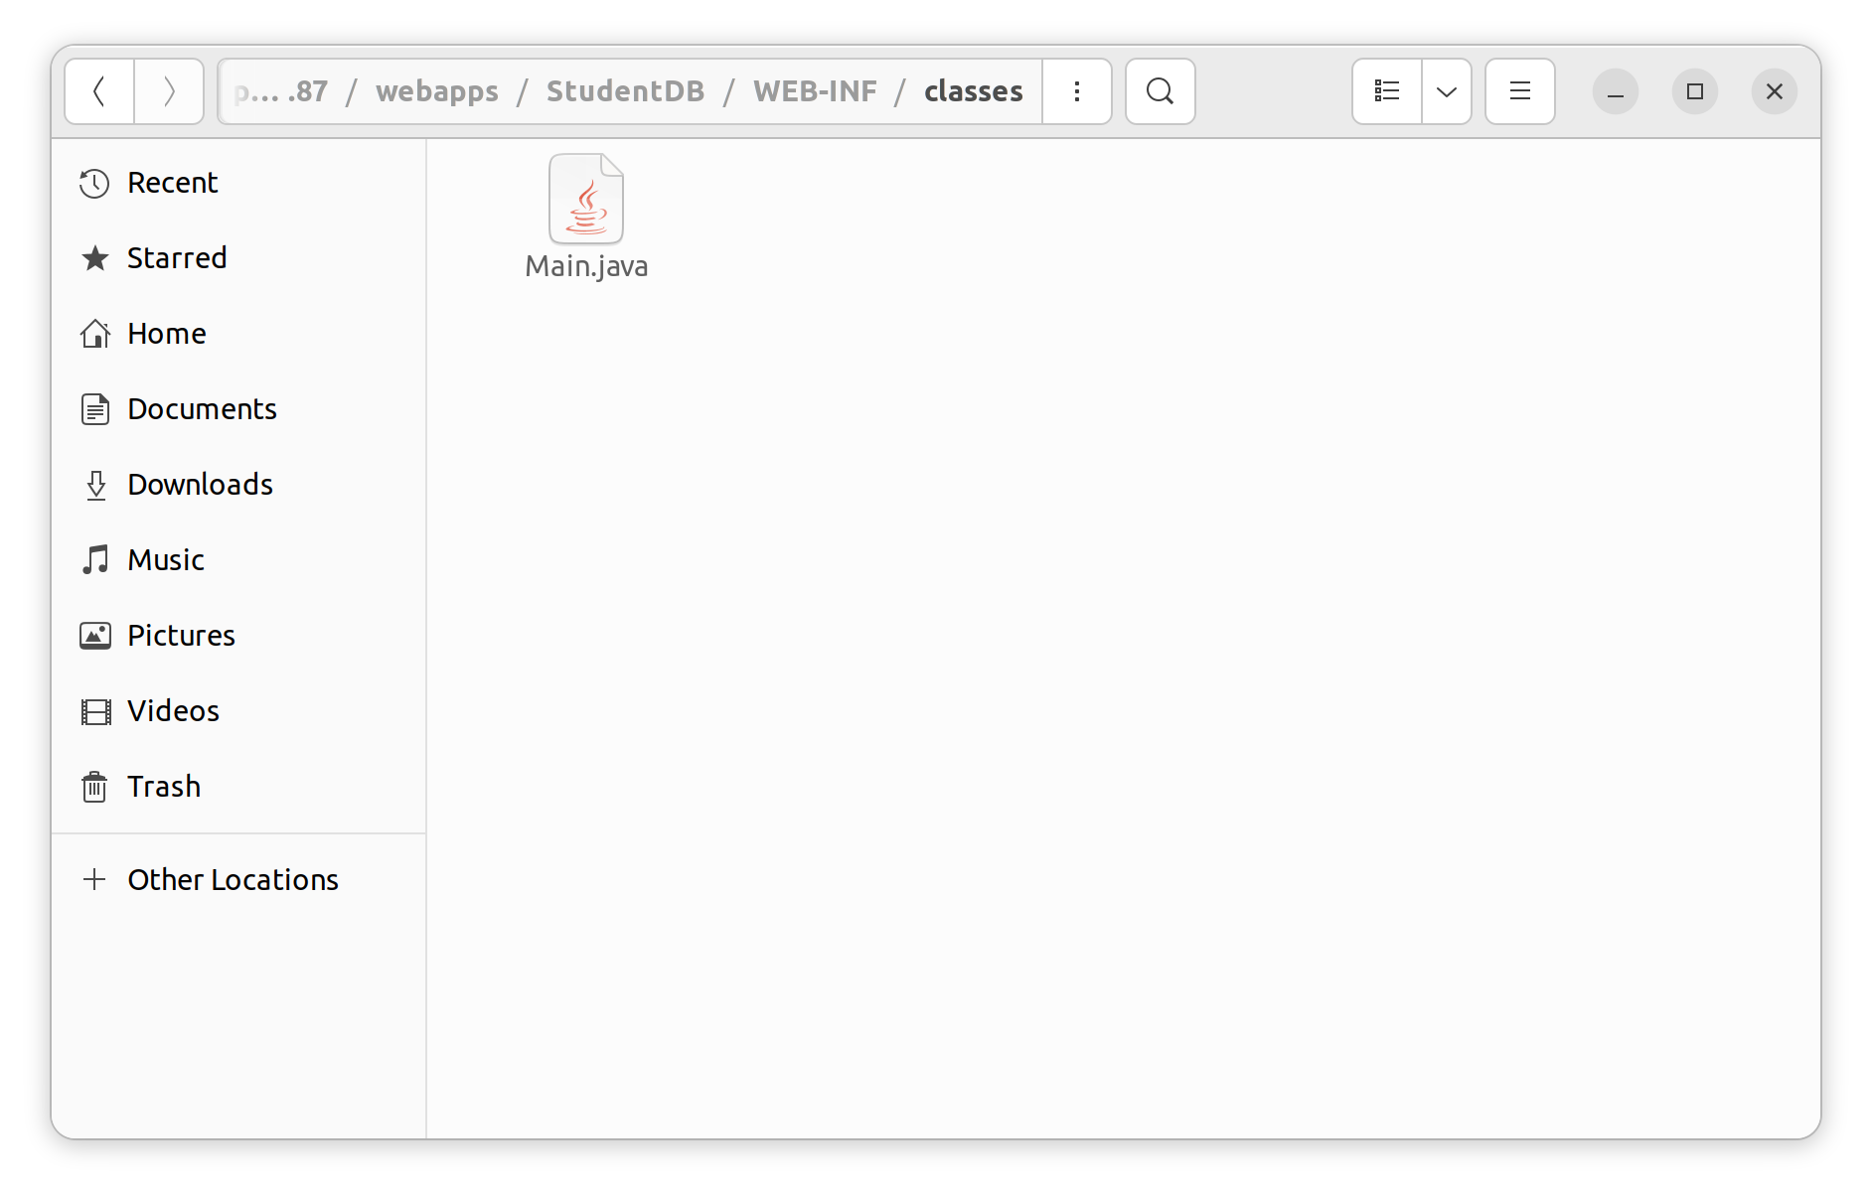

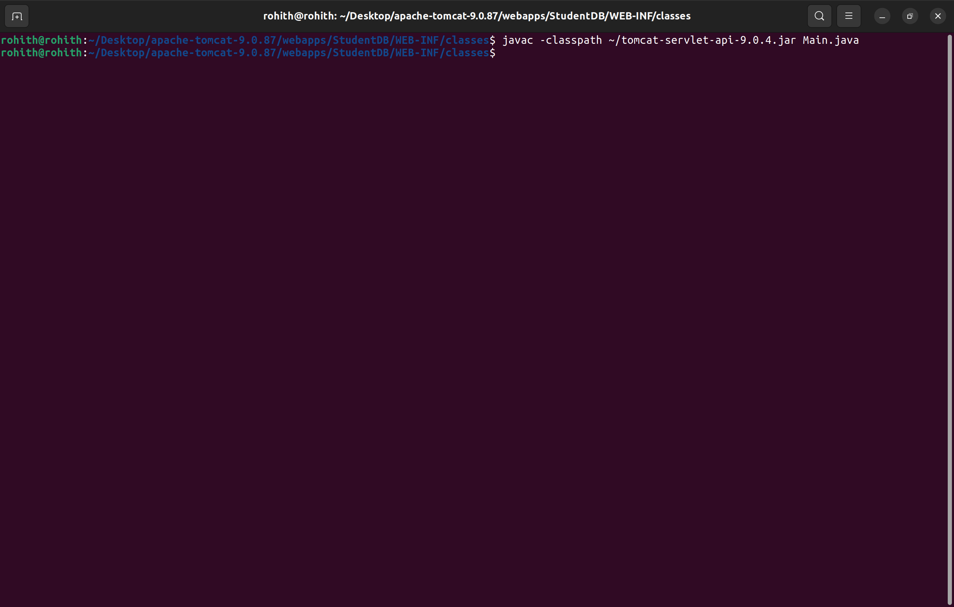
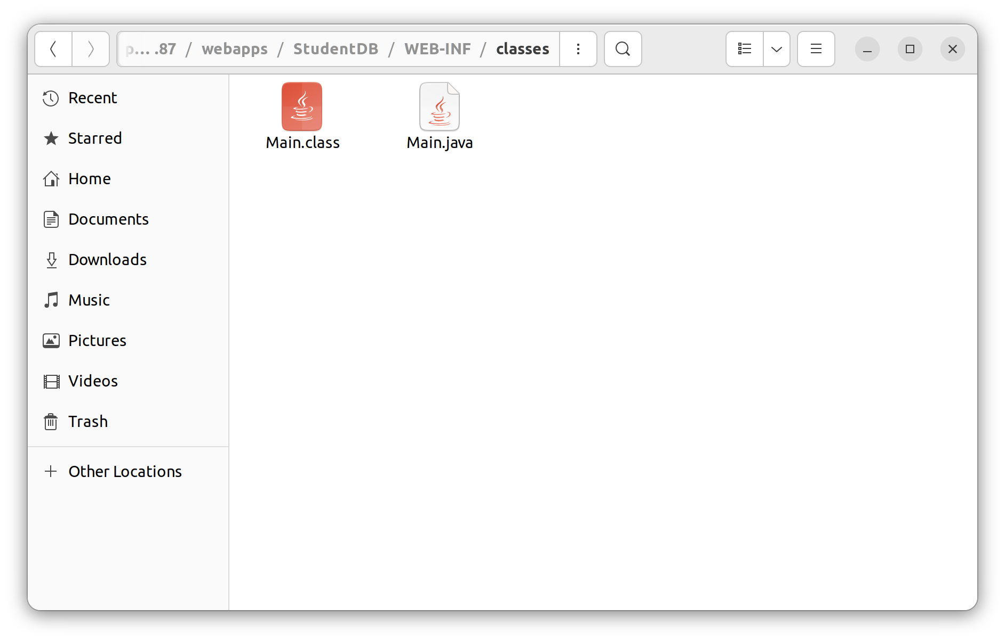
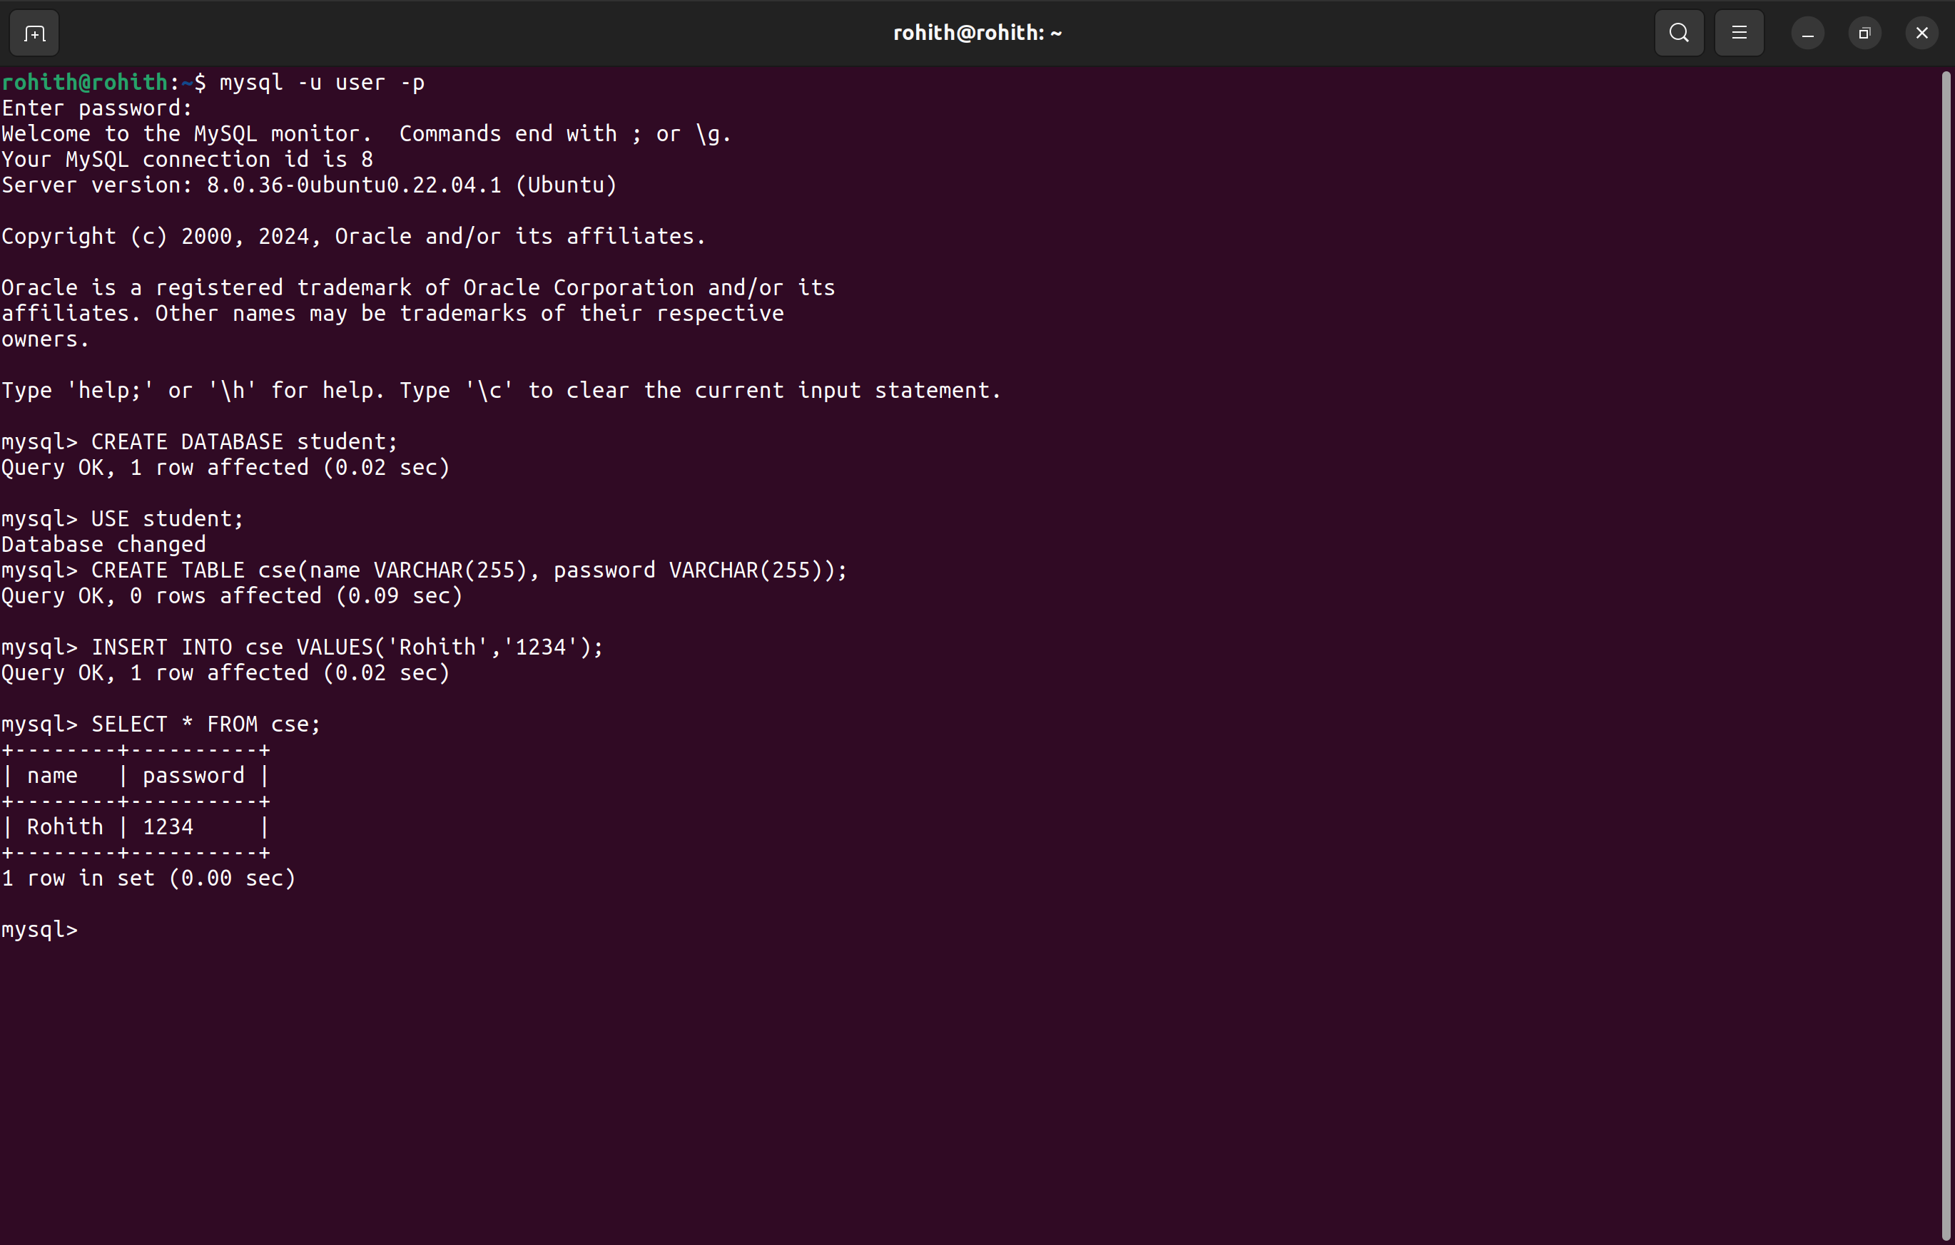
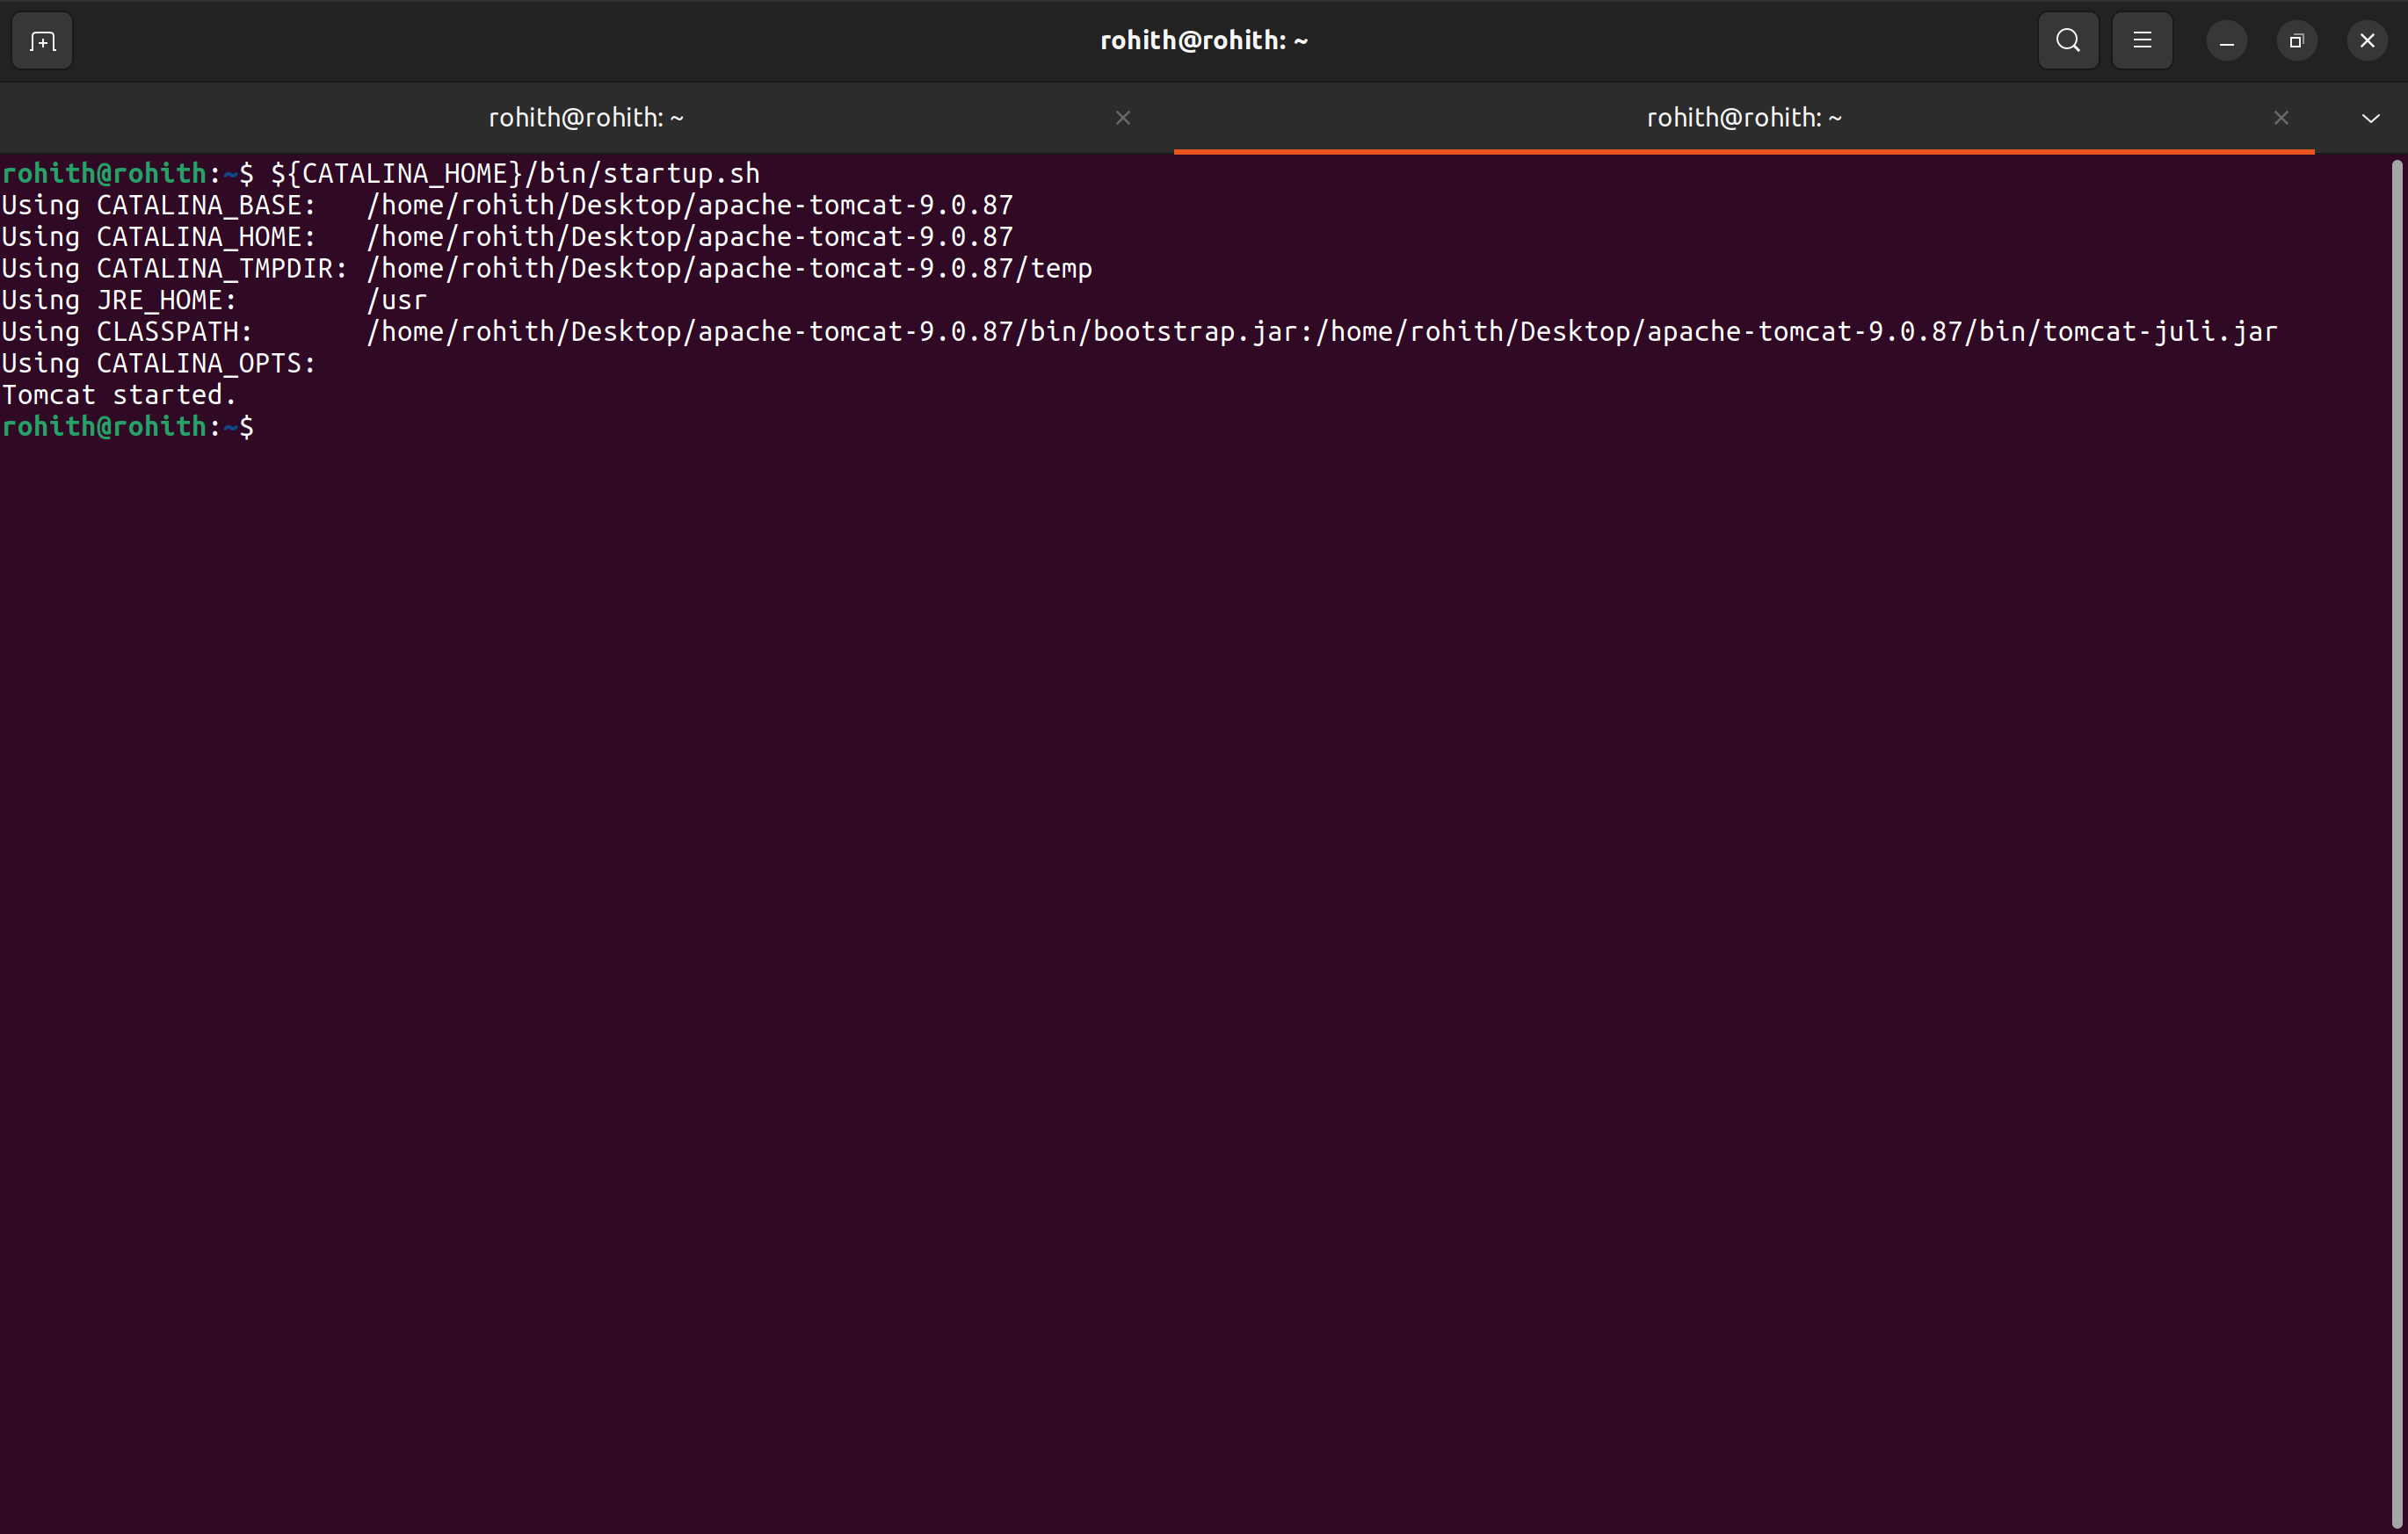
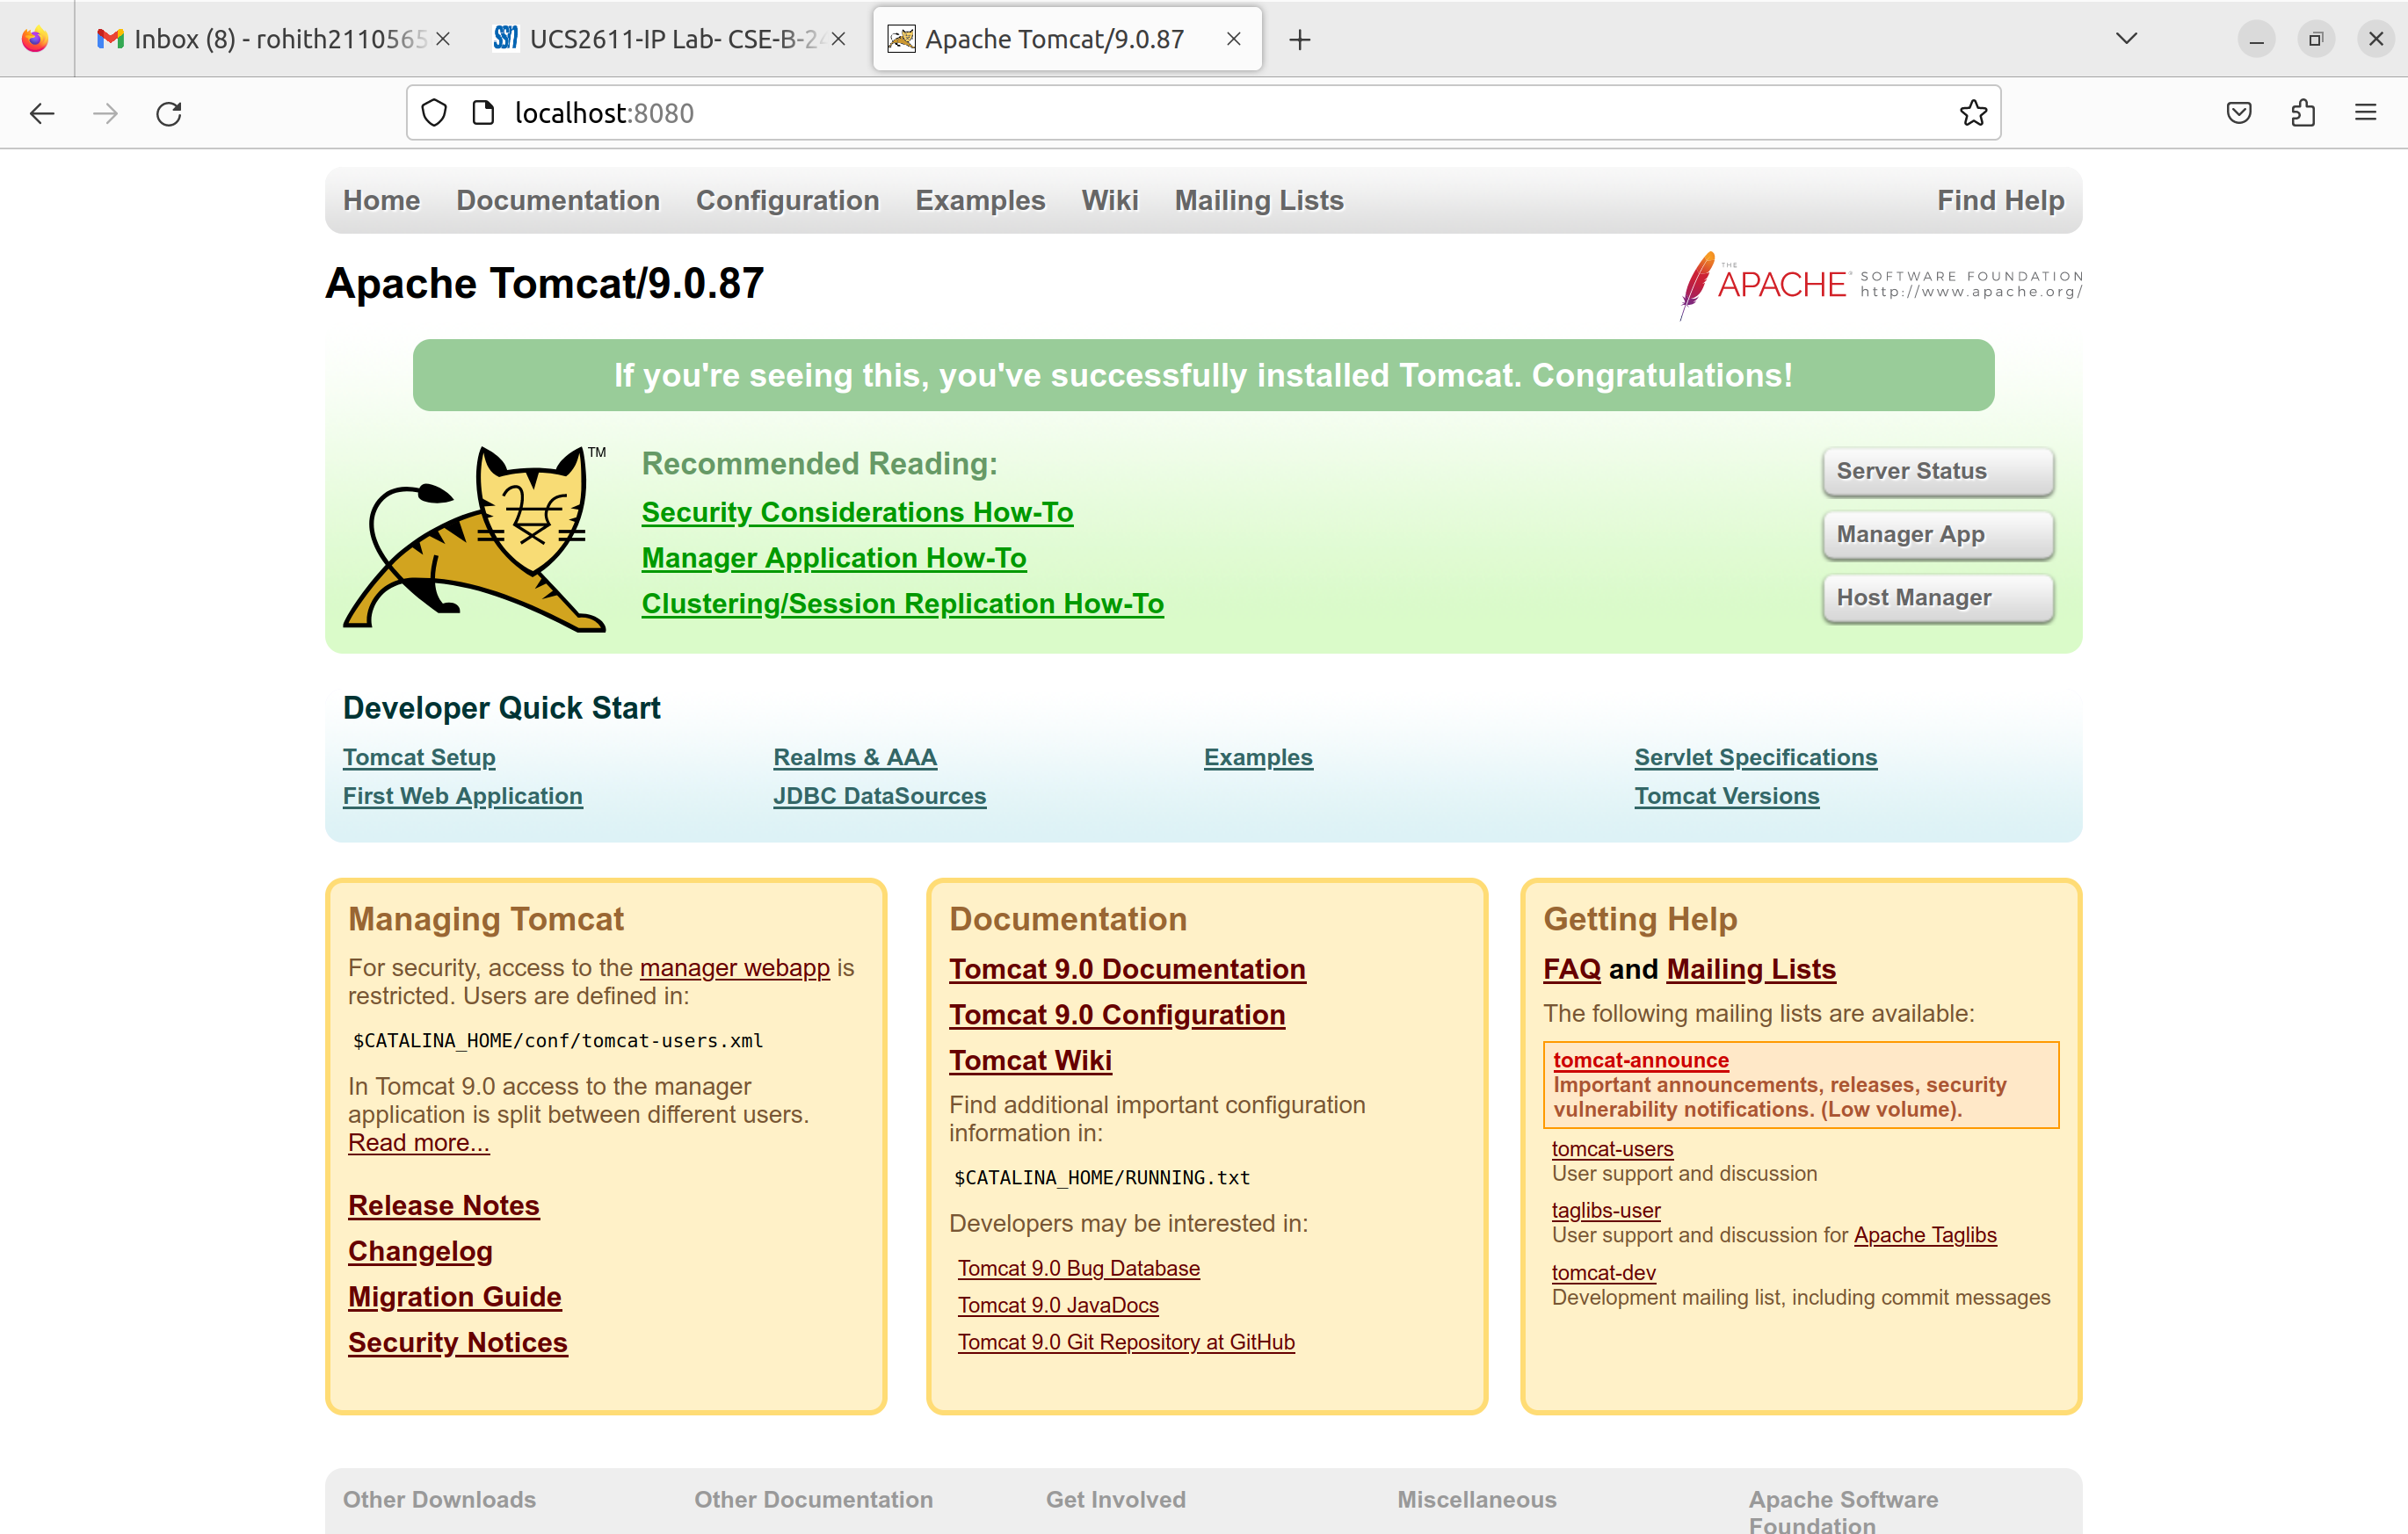
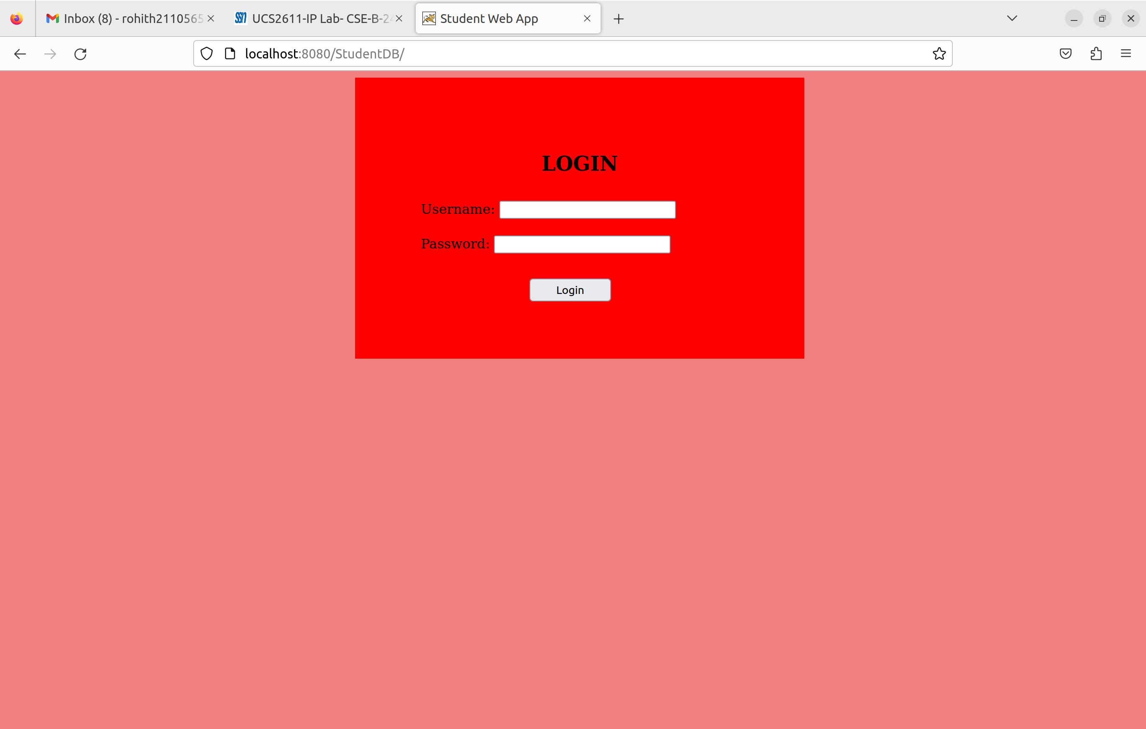
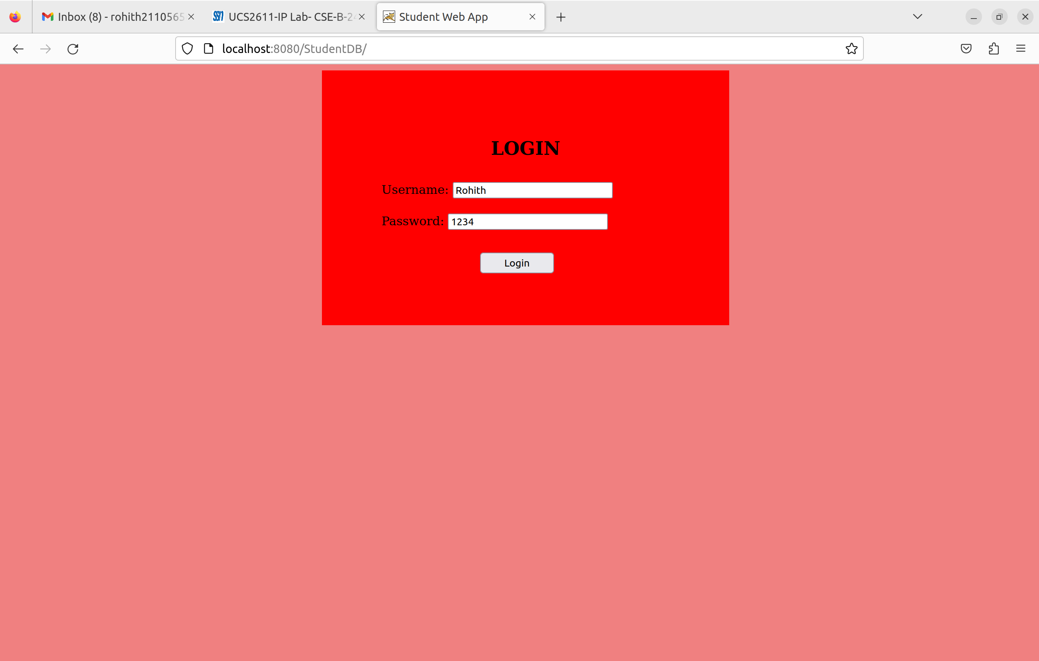
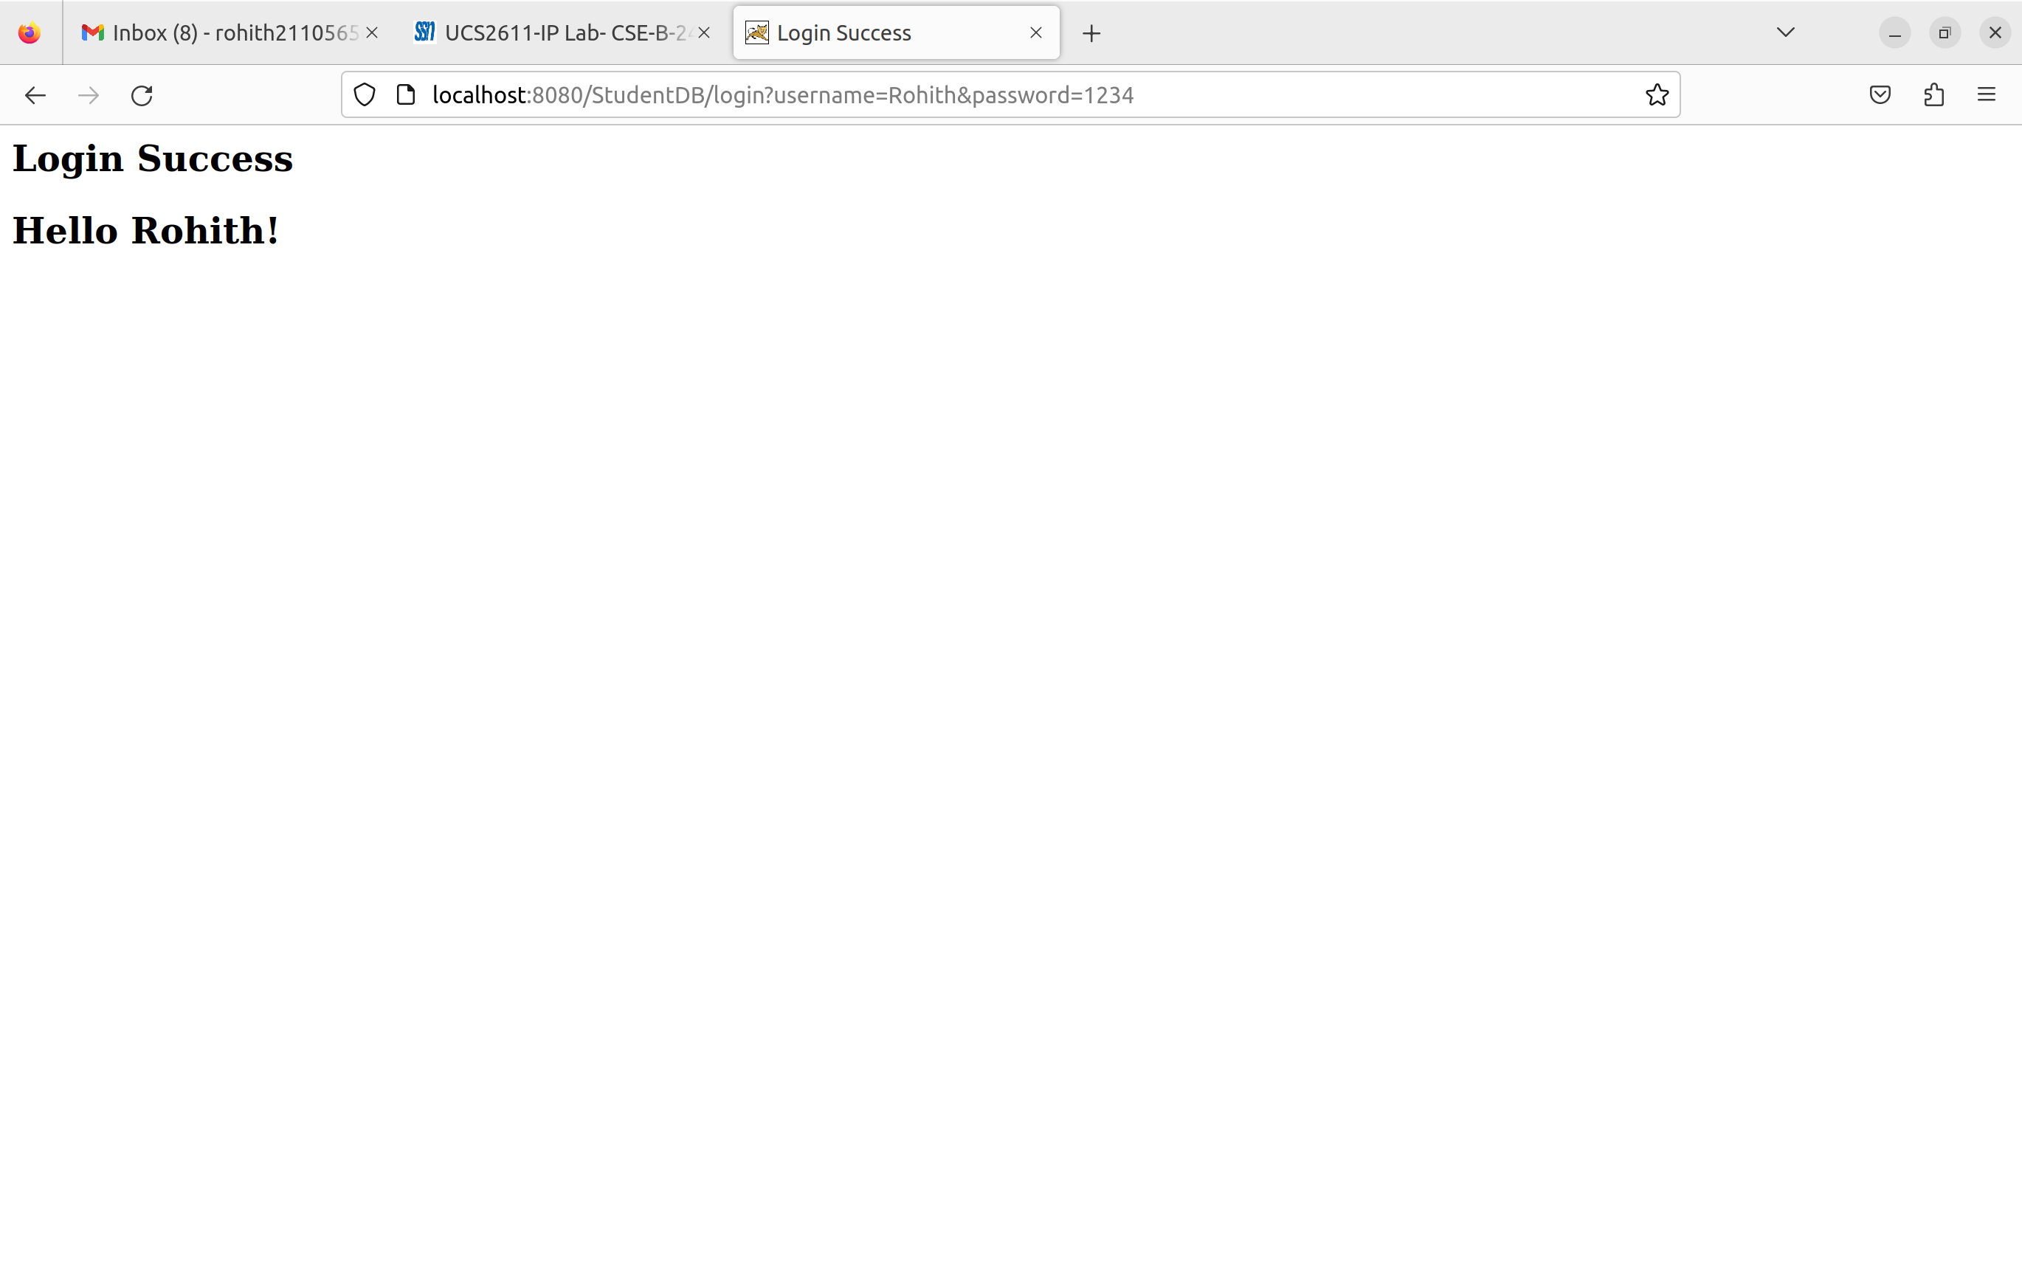
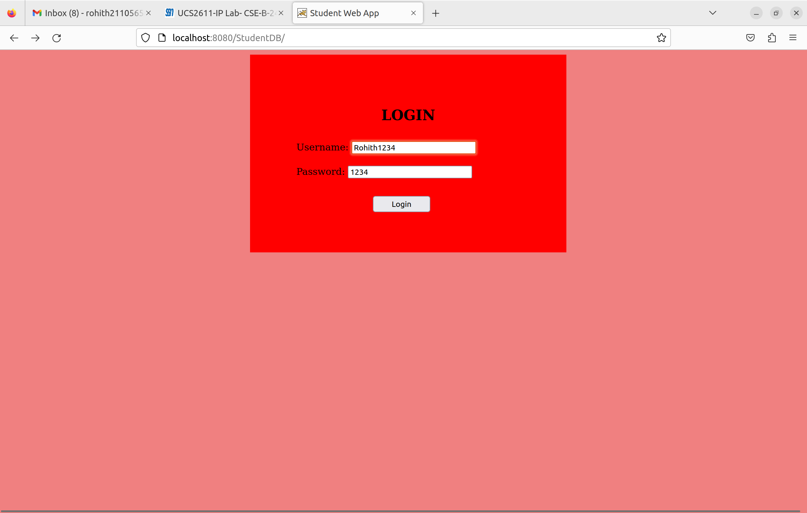
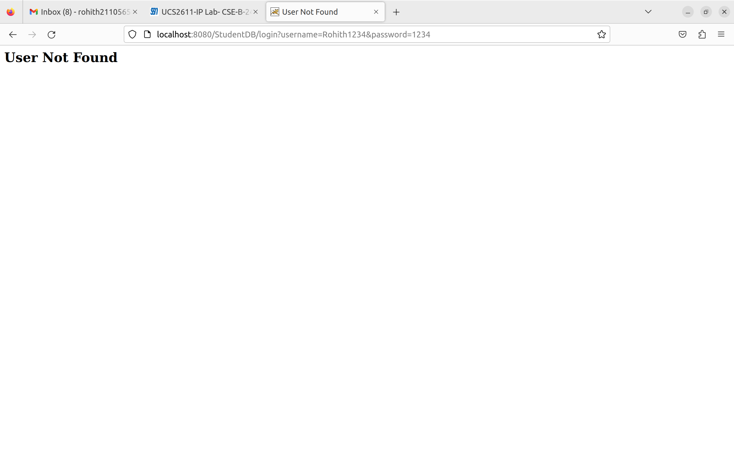
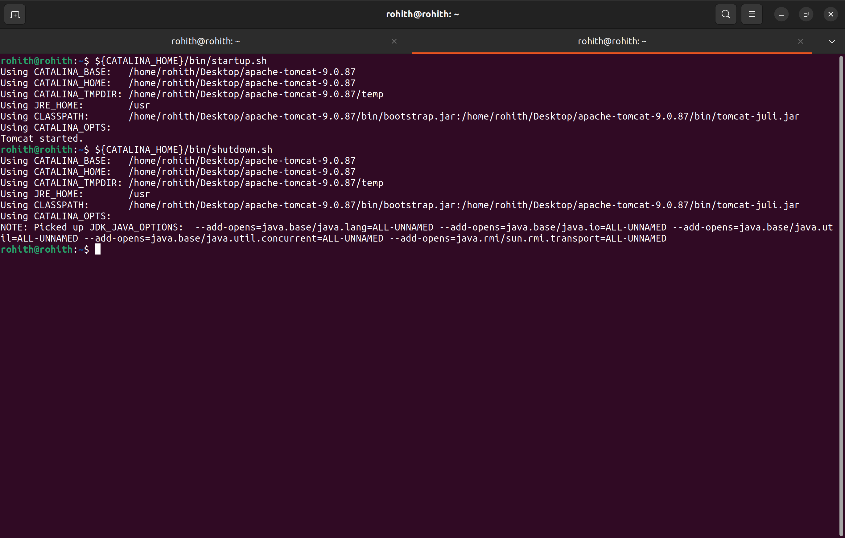

Learning Outcomes:

1. Understand the working of Server-Client and Database communication in Web Applications.
2. Developed a simple authentication web application using Tomcat + Java + MySql database.

